Create Eureka Discovery Service Project

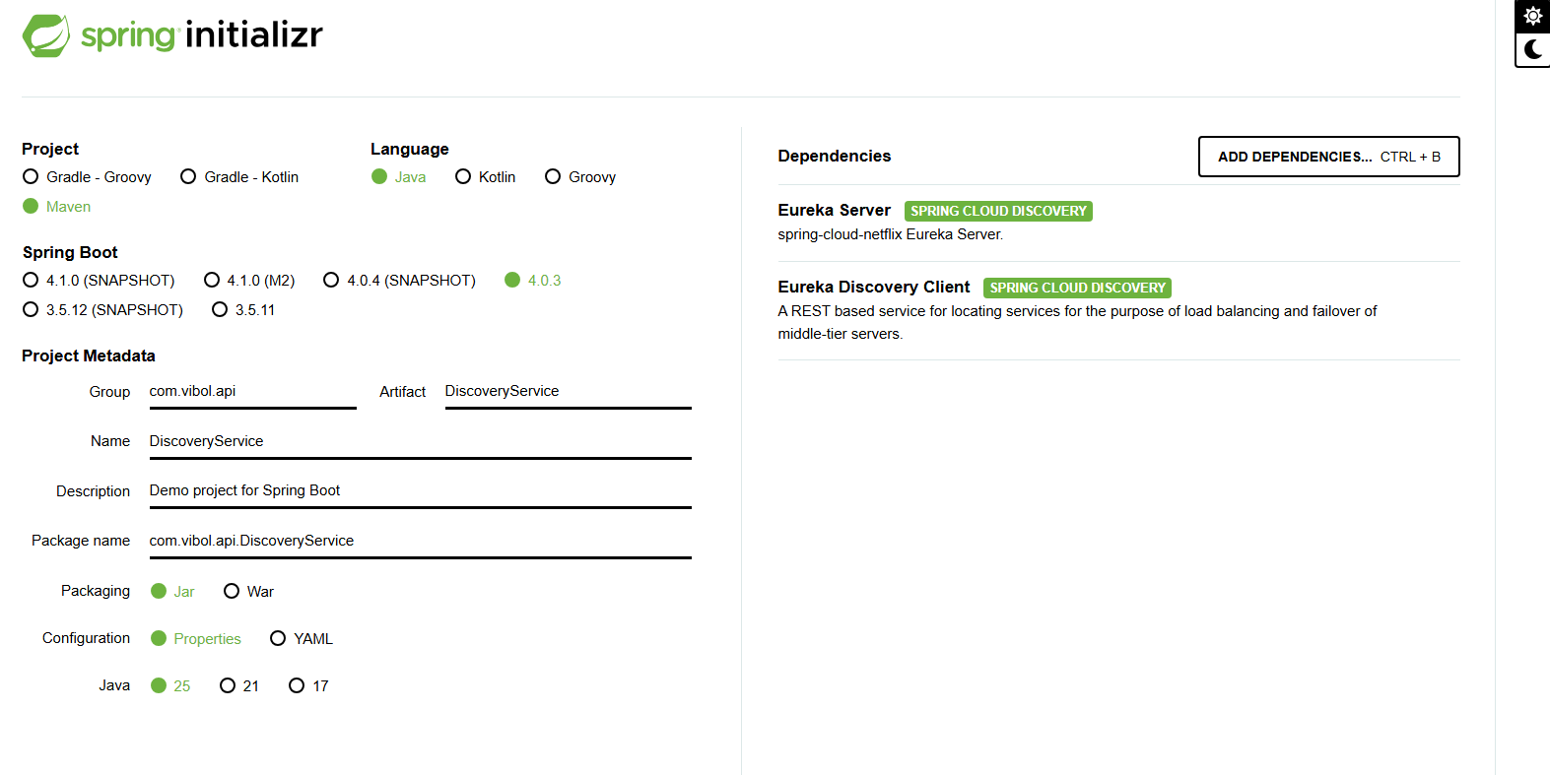

- Create DiscoveryService add dependany both : Eureka Server and Client because it can talk to each other and get the register from the other Microservice
- create bootstrap.properties : starter before application.properties

- ដំបូងបំផុត ប្រាប់ Spring Boot this is Eureka Service
Add the annotation on the application main running file

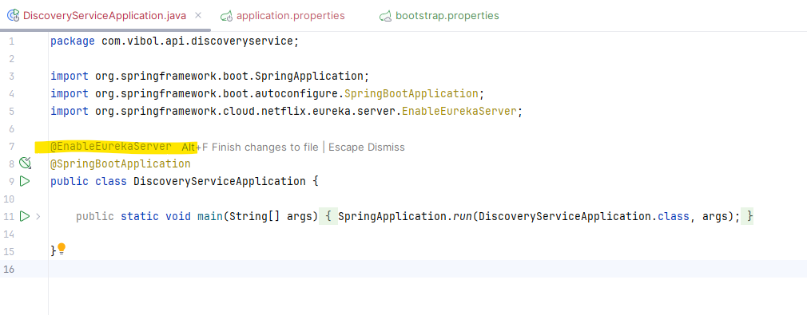

@EnableEurekaServer

- Add the application.properties
- Create bootstrap.properties : this start first ដើម្បីកុំអោយវាឃើញ properties ច្រើនពេលក្នុង application.properties

>> spring.application.name=discoveryservice

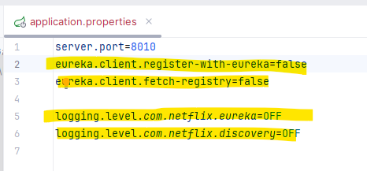

Explain:

Configure Eureka:

- ​server.port=8010 : port number of Eureka

- eureka.client.register-with-eureka=false សម្រាប់ Server នឹងមិនអោយចុះឈ្មោះជាមួយ Eureka ផ្សេងទេ ព្រោះវា ជា Eureka server ហើយ ដោយសារតែពេលវា បើកមក វាធ្វើការ Register ដោយខ្លួនឯងផ្ទាល់ Do NOT register itself as a client in Eureka.

- eureka.client.fetch-registry=false (Do NOT fetch the service registry from Eureka.)

- logging.level.com.netflix.eureka=OFF (This disables logs related to: Netflix Eureka internal classes)

- logging.level.com.netflix.discovery=OFF (This disables logs related to: Netflix Discovery client internals)

Running the Eureka:
